# Setting up .csv file before using pyOPAM

Ensure you have all the columns highlighted in yellow, even if you do not have data for them. Remember to remove spaces from these column headers. Save the file as *foo.csv* where *foo* is your preferred filename. The python script will read in a file with the name that you choose in the script.

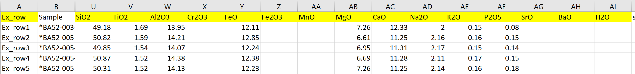

Ex_row is optional. Can have just “Sample” column but will need to change column names called in for indexing in the notebook (details in notebook).

# Accessing pyOPAM

The pyOPAM code is available as open source through GitHub. The code is available as a Jupyter notebook at [https://github.com/Rjmbx/pyOPAM](https://mybinder.org/v2/gh/Rjmbx/pyOPAM.git/HEAD) and those familiar with GitHub can clone the repository and run and edit locally. A more suitable option for those unfamiliar with GitHub is accessed by using either Binder or Colab to allow you to run the Jupyter notebook on a cloud server.

If you go to the GitHub website link shown above then click on the following “launch binder” badge then you will start Binder. You may prefer to try the other badge, “Open in Colab”, which will start Colab (e.g. if Binder fails to start)

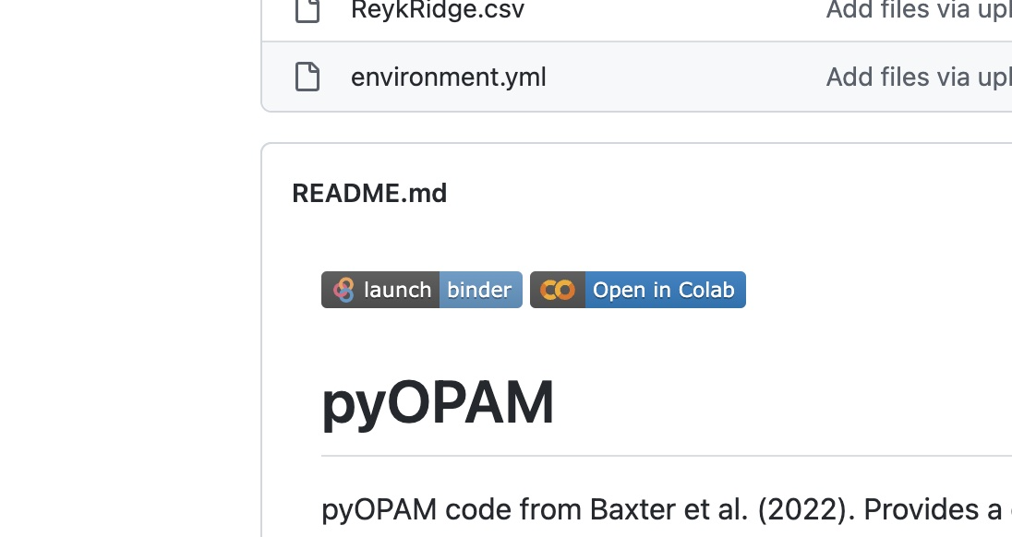

# Binder link to pyOPAM barometer

If it is the first-time Binder is building the environment and notebook for you, this may take 5 or 10 minutes. If it fails to load, close the page, paste the Binder link into a new page, turn off ad-blocker and try again. You shouldn’t need anything special on your computer to run Binder. It is also possible to visit mybinder.org and provide the URL for the GitHub repository – this has the same effect as clicking on the badge.

# Running pyOPAM in Binder

1. Double click on OPAM_barometer.ipynb file
2. When window is open save a local version of the notebook, download, or have your data file ready, if the notebook tab is idle for 10 minutes, binder will time out and the page will have to be reloaded.
3. Upload your csv file into the binder. Either drop the file in the LHS list containing the .ipynb file, or upload from your computer with upload button (red box highlights button below)

1. In the second code cell of the notebook change the name of the .csv file from ‘ReykRidge.csv’ to whichever file name you are investigating in line 6. For example, if you want to look at the Icelandic dataset used in this paper, change this to ‘OPAM_Compilation.csv’.
2. In line 12, change the name of the column from “Ex_row” to the column name of the first column in your .csv file
3. In the last cell of the notebook, change the output .csv filename from ‘OPAM_output.csv’ to whatever name you want to give your output csv file.
4. Once changes are made, go to the Run drop down menu, and select Run All Cells (yellow box below)

1. Your output csv file generated will appear in the LHS list of files.
2. Right click (or control-click) and download your OPAM output file. Both the pressure estimates and probabilities will be saved as new columns of the .csv file.

# Saving the Binder link or Jupyter Notebook for further work

There are two ways of saving the notebook for later editing. Save the changes you make to the Binder page with the save button (green dotted box) then either:

1. Save to browser (yellow box around box in below screenshot). This option is best if you don’t already have Python installed. This will save the notebook and any changes you have made to your browser storage. If you have saved the notebook to your browser, you can restore your progress if the page crashes by;
   1. Close crashed page.
   2. Re-paste original Binder link into browser URL.
   3. Open up .ipynb file.
   4. Restore previous work from browser storage (shown in green box below)

1. If you want to work on the notebook offline or in a different format if you are familiar with working in Python, you can make changes, save, and download the notebook to work on elsewhere.

# Troubleshooting in Binder

If struggling to load link, turn ad-blocker off for binder pages and reload. It is possible to operate Binder with ad-blocker on but sometime this can cause the environment to fail being build and binder to fail to load.

**Binder becomes unstable if left for too long**. Connection to host site will time out if tab left inactive for >10 minutes. If the page times-out and you refresh, you will run into a 424 error (screenshot below)

If this happens, close page and re-paste binder link into your browser URL.

# Running pyOPAM in Colab

The easiest way to get Colab started is to click the badge on the GitHub repository. An alternative is to navigate to colab.research.google.com and open the GitHub repository from there.

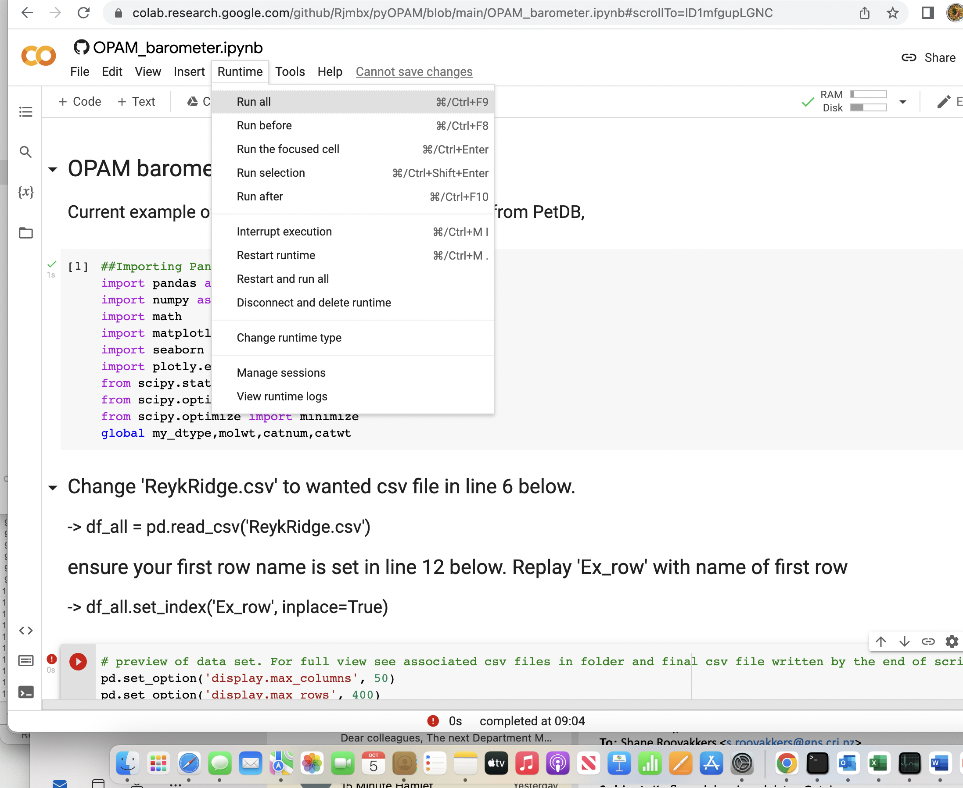

You can then select “Run all” from the Runtime menu above, which will run all of the cells. You will be warned that the notebook wasn’t authored by Google but you should proceed to run anyway. You will find the error below.

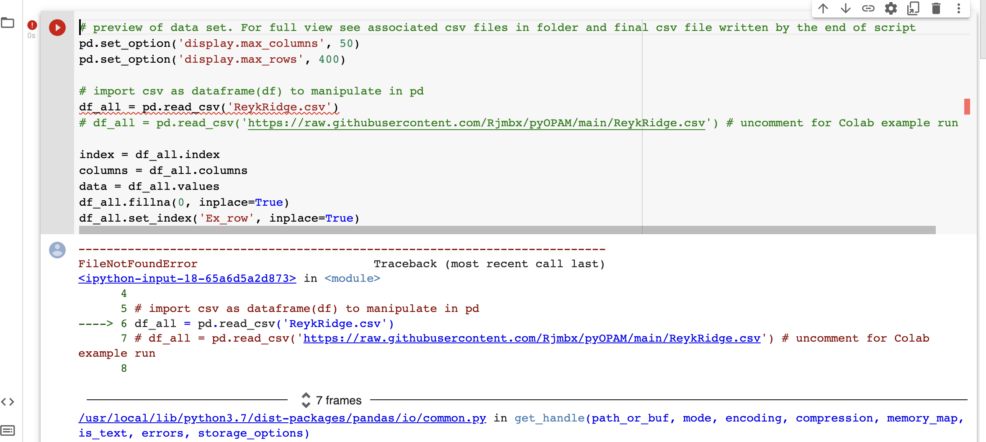

This is because the example data file ‘ReykRidge.csv’ is not loaded into the Colab system. So, you need to add and remove comments (the # sign in python) so that the code looks as follows.

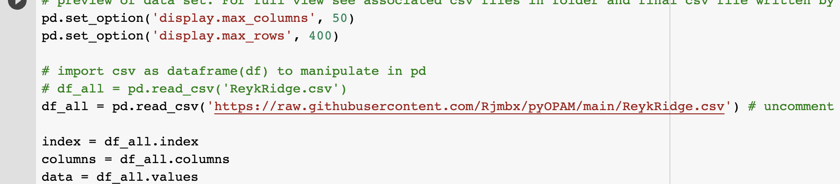

Now the notebook is reading directly from the GitHub repository and you should be able to go back to ‘runtime’ and ‘run all’ the cells without an error.

1. Saving output and loading new data in Colab

To save the output file ‘output.csv’ you first need to access the file structure by clicking the folder icon on the left-hand side of the window – highlighted in orange below. Hover over the filename and click the column of 3 dots next to filename. Select ‘download’ to download the file to your local computer.

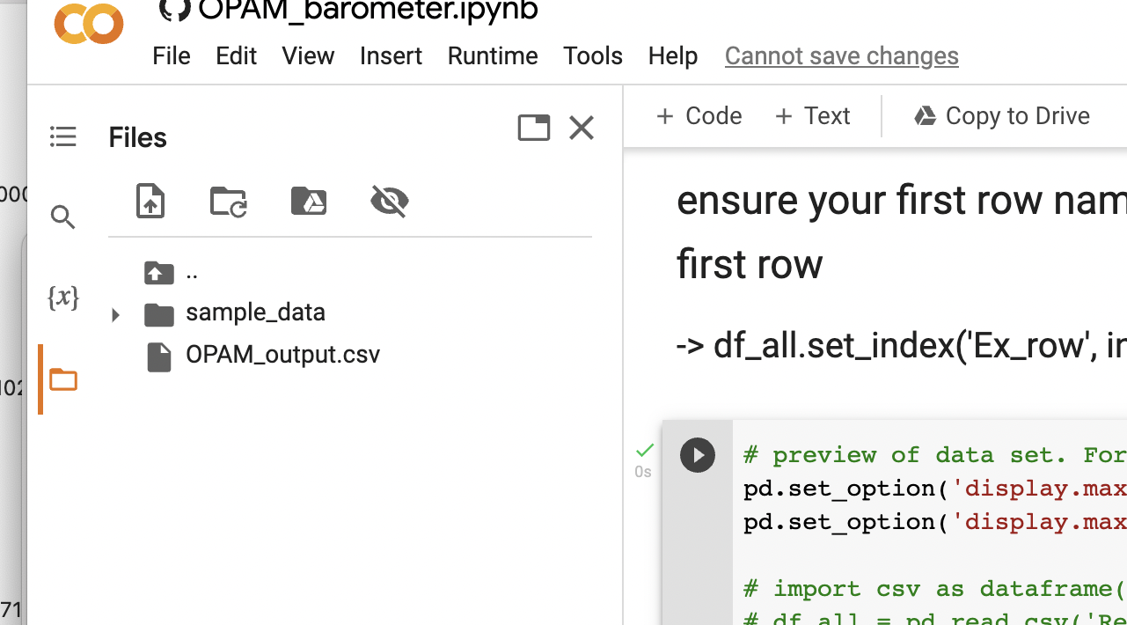

To save your edited Jupyter Notebook go to File > Download > Download.ipynb

To return to a previously saved notebook on your local storage go to File > Upload notebook

When you want to read in your own data (e.g. foo.csv) then you can drag and drop the file into the white space shown below ‘OPAM_output.csv’ in the screenshot above. Then, change the text that reads in the csv to show the filename in the folder, as shown in the screenshot below.

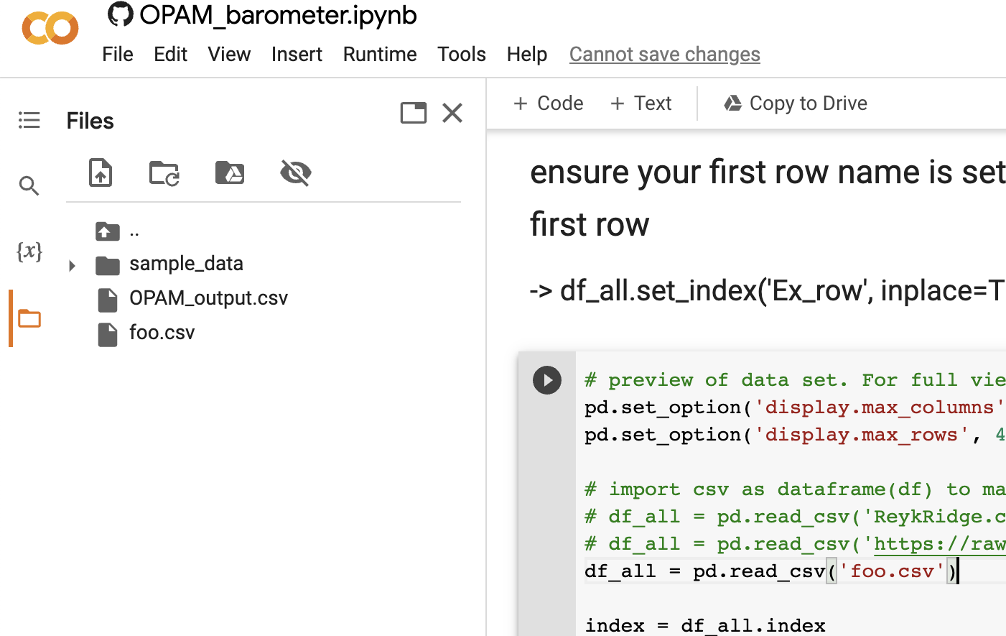

Go to Runtime > Run all and your data will be processed to provide a new output file.